**HOME-BASED PATIENT MONITORING SYSTEM REPORT**

PART A:PROBLEM STATEMENT

In majority of the developing countries, specifically in Africa, access to continuous and accurate health monitoring systems in remote or home settings, specifically for patients with chronic diseases and the elderly has been a major challenge.In Kenya , IoT technologies have been intergrated in the healthcare sector with an aim of overcoming this particular issue and improving healthcare delivery.However, the large-scale deployment of the intergrations is still emerging.Here are some of the notable initiatives that highlight the application of IoT in addressing the home-based patient monitoring issue in Kenya:

**AfyaRekod**-This is a health data platform that intergrates IoT-compatible features such as wearable devices for real time data tracking and allows patients and doctors to access health records remotely .

**Intel’s Smart Health Initiative**-In collaboration with local stakeholders, Intel has intergarted IoT devices in remote clinics which track patients’ vitals and transmit data to a central systems enabling real-time monitoring and quick interventions. This innovation could be adapted for home patient care especially for monitoringchronic or elderly patients

**Philips Community Life Centres-**Philips has partnered with the Ministry of Health to develop Community Life Centres that intergrate IoT systems to provide remote consultations and patient monitoring though not specifically home-based.

Several Kenyan universities such as University of Nairobi and The Jomo Kenyatta University of Agriculture and Technology have ongoing research on IoT- based healty monitoring systems. Students have developed prototypes using microcontrollers ans sensors wich transmit data on web dashboards.

**OBJECTIVES OF THE PROJECT**

This project aims at building upon the existing body of work by designing a low cost, home-base health monitoring prototype that monitors vitals such as oxygen saturation, temperature and heart rate using the relevant sensors and a microcontroller that processes and transmits sensor data to a web dashboard.

The prototype share similarities with the university-based research but aims at bridging the gap between academia and real world deployment by using open source tools and platforms that are easily adaptable and includes alert mechanisms making it more responsive to critical health changes that requireimmediate attention.

**PART B:IoT FRAMEWORK ARCHTECHTURE**

This IoT-based home patient monitoring prototype is designed using the following architechture

**Sensors-**DHT22 which measures the temperature

MAX30102 which measures oxygen saturation and heart rate

**ESP32 microcontroller** that collects sensor data and processes the data locally

**HTTP protocal** which transmits sensor data in real time from the ESP32 to the web server via the internet

**Actuator-**virtual actuators give visual alerts on the caregivers’ dashboard interface while a buzzer alerts the patient in the room when values go beyond safe thresholds

**Cloud-** lovable.app platform hosts the wed dashboard. The backend logic recieves sensor data from the ESP32 and stores it temporarily

**User interface-** a web dashboard displays real time sensor values, shows alerts when values exceed safe ranges and also the medication reminder.

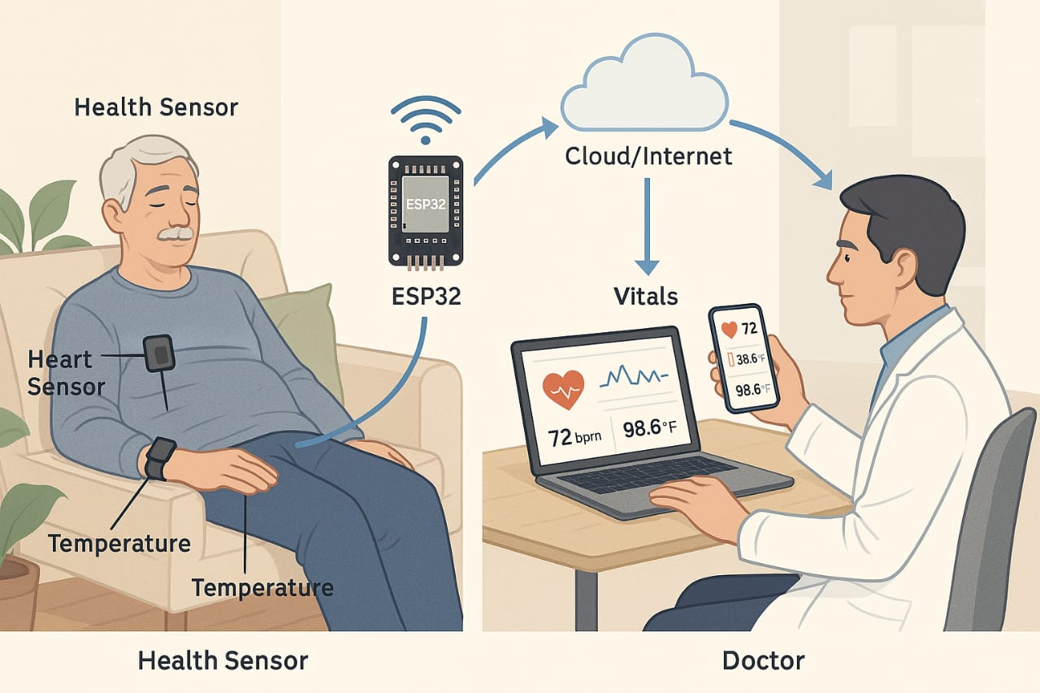

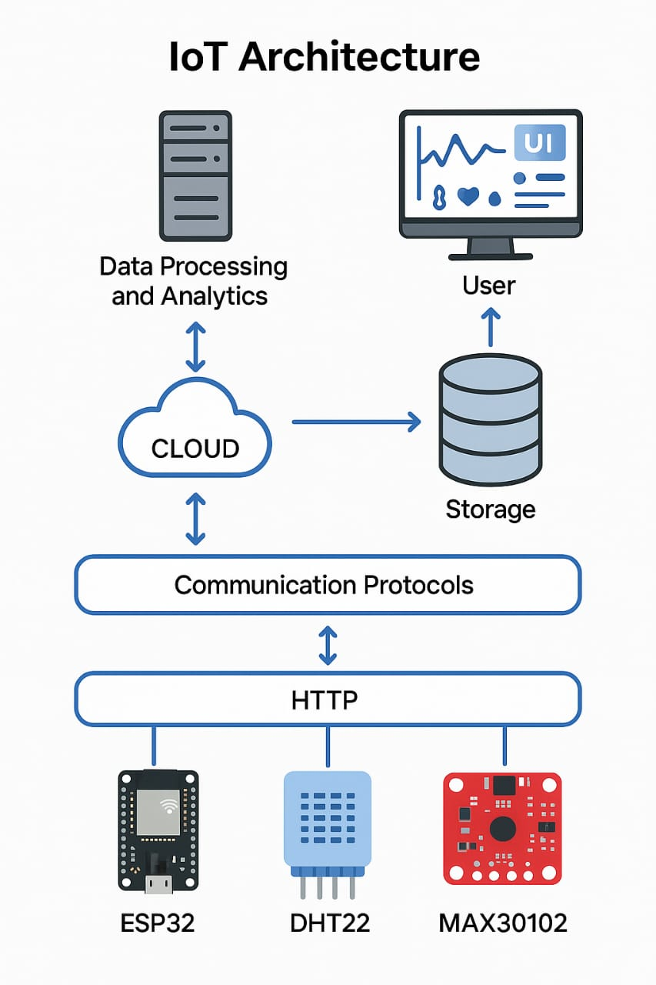

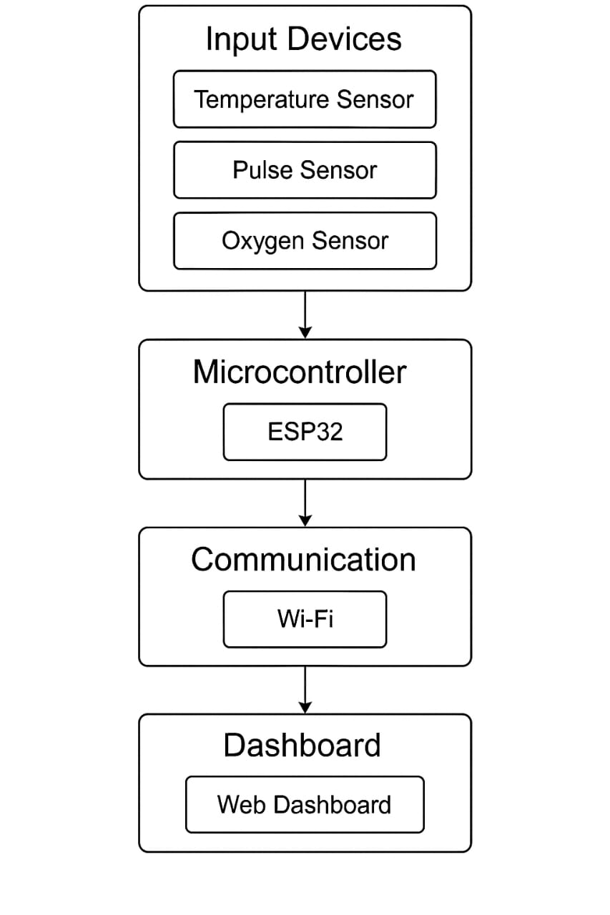**Justification for the chosen components**:

* ESP32 microcontroller has an in-built Wi-Fi module which enables it to be used as both a microcontroller and a network gateway hence simplifying the setup
* MAX30102 measure both heart rate and oxygen saturation which also simplifies the setup
* DHT22 sensor was chosen for its accuracy in measuring temperature and it was best compatible with ESP32
* HTTP protocol is reliable and easy to implement
* The virtual actuators( pop-up alerts) show alerts remotely on the dashboard and the buzzer alerts the patient and the caregiver physically

**Data privacy**

The system ensures patient data privacy is a top priority.It minimizes exposure of patients’ sensitive such as names, location,and finances by collecting essential data like temperature and heart rate

The front end dashboard is only accessible to the relevant users such as the care givers and the health professionals

**Security**

The system is designed to safeguard the confidentiality of the transmitted data .Communication between ESP32 and the cloud uses HTTP protocols which ensures the data sent over the internet is encrypted and protected from tampering.The backend includes validation logic to sanitize incoming sensor values an block unauthorized requests

**Scalability**

The architecture of the system is scalable allowing allowing increase in system complexity with the growth of user needs. Multiple ESP32 devices can be added to monitor different patients at the same time. The dashboard can be extended to show history logs , charts and multiple patient data cards

The system’s modular design allows new sensors such as ECG and blood pressure or new features such as voice alerts to be intergrated with minimal changes involved

This makes the system capable of transmiting from a prototype to a production ready solution to home healthcare.

**Part D:Evaluation and future work.**

Evaluation

The prototype was evaluated based on key metrics such as accuracy and responsiveness , user experience and cost and feasibility for large-scale deployment.in terms of **accuracy and responsiveness**, the system performed well by offering real time data collection from the sensors and immediate feedback for users via the web dashboard. The sensors captured temeprature , oxygen saturation and heart rate accurately . Alerts were triggered promptly when thresholds were exceeded.

For **user experience,** the system focused on ensuring simplicity and accesibility. The web dashboard was designed to display real time sensor data in a visually engaging format to allow both patient and caregivers to easily interpret health conditions without requiring technical expertise.The system is accesible across device whether mobile or desktop.

Regarding **cost and feasibility** for large scale deployment in kenya , the system proves to be highly promising. Components such as ESP32, DHT22 and MAX30102 are low cost and readily available in the market both locally and internationally making the system affordable for larges scale adoption.The use of web-based platforms for data visualization repleces the need for expensive proprietary software.

FUTURE WORK

There are several areas in the systen that can be improved or expanded .

**Access controls** such as password-protected logins or token-based authentification can be added to improve data protection.

**Additional sensors** such as pulse oximeters or blood pressure sensors could be intergrated to provide a more comprehesive patient monitoring

The system could be transisted from stimulated

-based components to **real physical hardware** for more accurate and reliable data collection

**Machine learning** could be incorporated for predictive health analysis and expand the system to support multiple patients simultaneously

The last proposal is the intergration of a **cloud storage** like Firebase or Blynk to store patient health data for long term monitoring and historical analysis.

In concluson, The prototype demonstrates the potential use of IoT in improving home-based patient monitoring and tracking. It offers a cost effective , scalable and accesible solution for the problem faced in the healcare sector particularly for monitoring patients with chronic diseases and the elderly remotely.

***THANK YOU***